Skills Workshops 5: Seminar on Journal Article Writing - Session 1 and 2

Speaker: Dr. Anant R. Kukreti, Director for Engineering Outreach Professor, Department of Chemical and Environmental Engineering
Date: Monday, June 25, 2018
Time: 9:00-10:00 am
Venue: University of Cincinnati, Swift Hall Room 608

Prepared by:
Beth Francis, Felicity Franklin Schools, Felicity Ohio
RET Participant for Project #3 “Bio inspired Optimization of the Multiple Traveling Salesman Problem”
and
Paul Schember, Norwood Middle School, Norwood, Ohio
RET Participant for Project #1 “Membrane Bioreactor System for Wastewater Recycling and Recovery of Phosphorus from Wastewater”

This session was given by Dr. Anant R. Kukreti, on Monday, June 25, 2018 from 9:00-10:00 am at the University of Cincinnati in Swift Hall, Room 608. Dr. Kukreti is Director for Engineering Outreach for the College of Engineering and Applied Sciences and Professor in the Department of Chemical and Environmental Engineering and is the Principal Investigator of the RET Site Program.

Dr. Kukreti opened his first Journal session by defining the reason for doing research as the way we make our world a better place, see Figure 1 below. If we don’t share our results, then why even do the research. Technical writing is how we present the results of research. In higher education technical writing is embedded as part of their job but for K-12 it is desired, but not required.

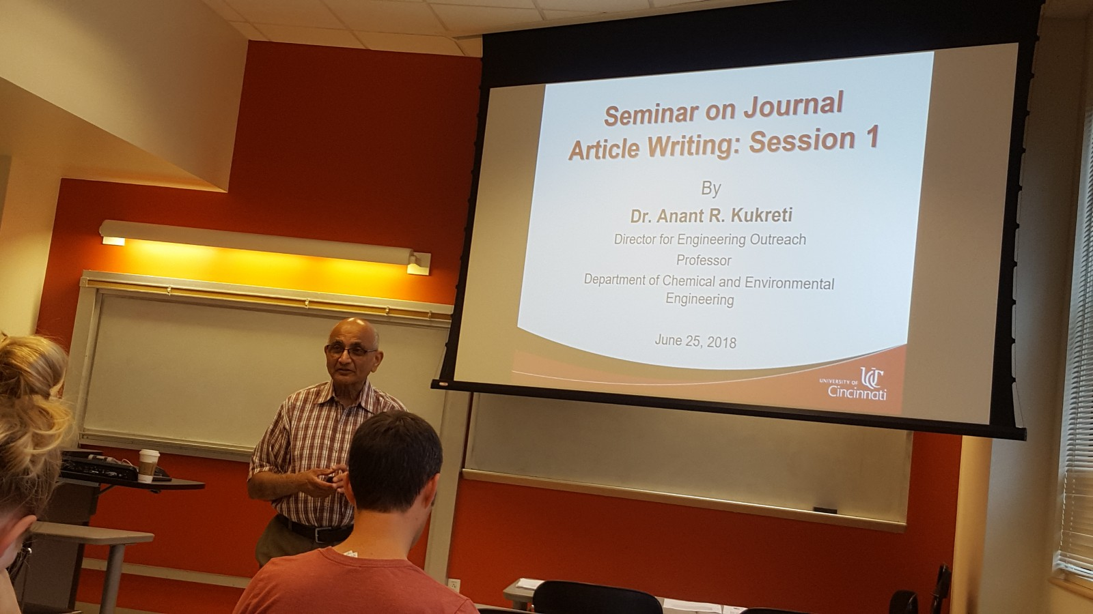  Figure 1: Dr. Kukreti Defining Research | 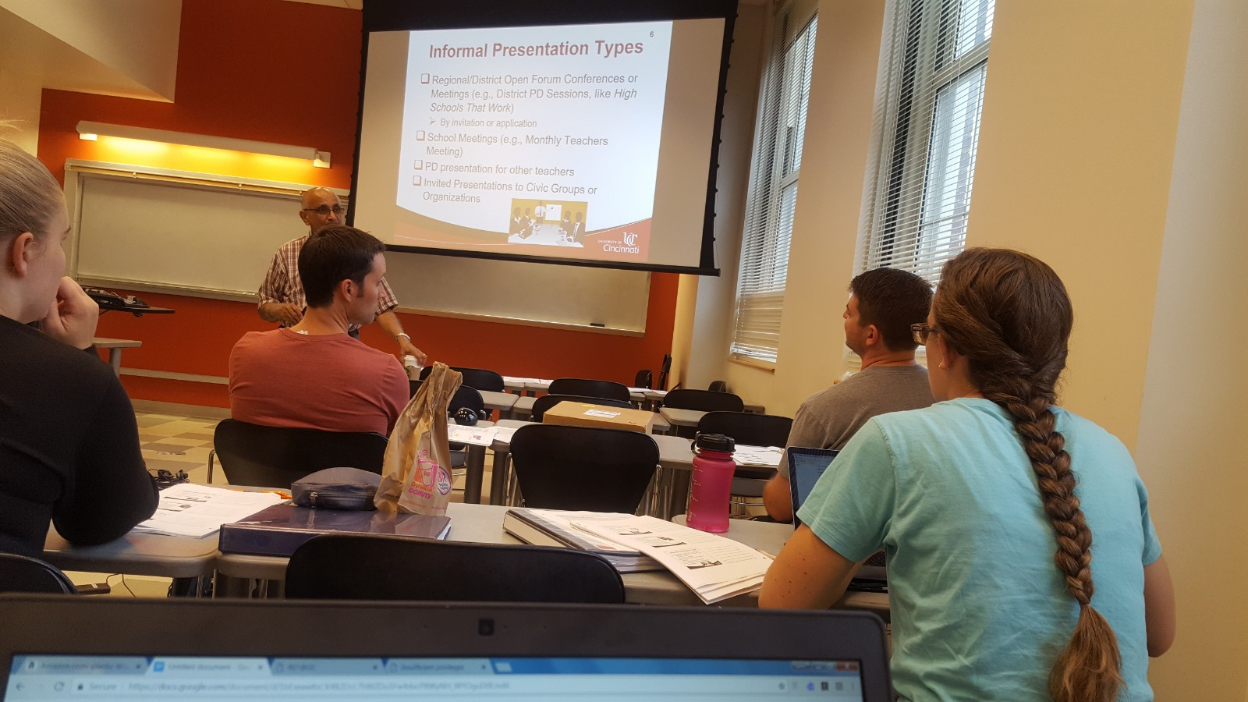  Figure 2: RET Teacher Answering Question

The first topic of discussion was the difference between formal and informal publications and presentations. To begin the discussion, Dr. Kukreti asked the RET participants what they thought the difference was between the two types of publications. The RET Participants answers led to Dr. Kukreti sharing the definitions of both. Formal format is a fixed format that is archived for public dissemination. Informal is not archived for public dissemination. As part of this topic, dissemination opportunities were discussed. Dr. Kukreti presented that publishing a paper/article/presentation is a formal opportunity and PowerPoint and poster presentations are generally not formal.

The second topic of discussion was to provide examples of formal publications and informal presentations. Formal publication was the first type discussed. Dr. Kukreti began the discussion by asking the RET Participants for examples of magazines commonly used by K-12 teachers to publish their teaching experiences, see Figure 2 above. Dr. Kukreti used this discussion to distinguish between a journal and a magazine. RET Participants provided examples of magazines. Using these examples, Dr. Kukreti defined a journal article as a way for presenting results of research which includes the literature review, goals and objectives of the work presented, research methods used, results and findings, and conclusions. It tells a story so others can use the research findings. Journals also have a formal editing process that must be followed. Magazines also tell a story but not necessarily a research story, more likely a personal unique experience in developing, teaching, assessing, reporting student learning results, and personal reflections for delivering a curriculum. Magazines are still considered formal publication types. Dr. Kukreti stated the difference between the two would be the editing process and the writing style. Dr. Kukreti then discussed the various conference publication types. During this time, the common types of conference publications were defined. The first type that was shared was a conference paper with presentation. This would include the full paper being published in the conference proceedings accompanied with a PowerPoint presentation. The second type shared was a conference paper with a poster. This would include the full paper being published in the proceedings and a poster presentation. The third type shared was the conference poster presentation. This would include a poster presented and an abstract published in proceedings/web/program. Dr. Kukreti warned to be careful when identifying the type of publication ensuring it is the right type. After discussing the formal publication types, Dr. Kukreti shared a list of informal presentation types. The types shared were: regional/district conferences or meetings, school meetings, professional development workshops or presentations offered for other teachers or civic groups or organizations. At this time, Dr. Kukreti discussed the informal presentation requirement of the RET Site Program which was further developed later in the presentation. Each participant received an example of a journal article, conference paper, a magazine article, PowerPoint poster, and a handout containing a detailed list of possible venues for publication. The handout includes associations, conferences and journals names, as shown in Figure 3 below.

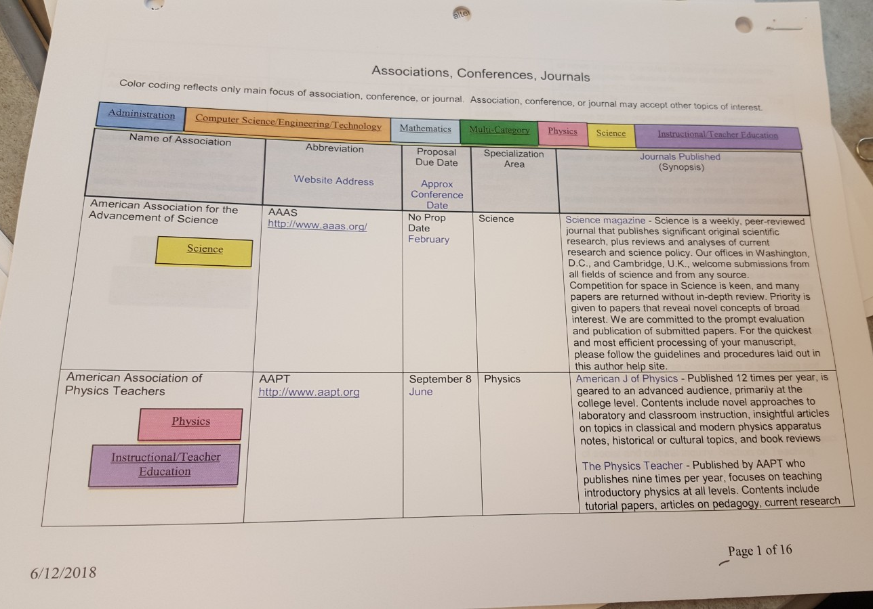  Figure 3: Possible Venues Handout | 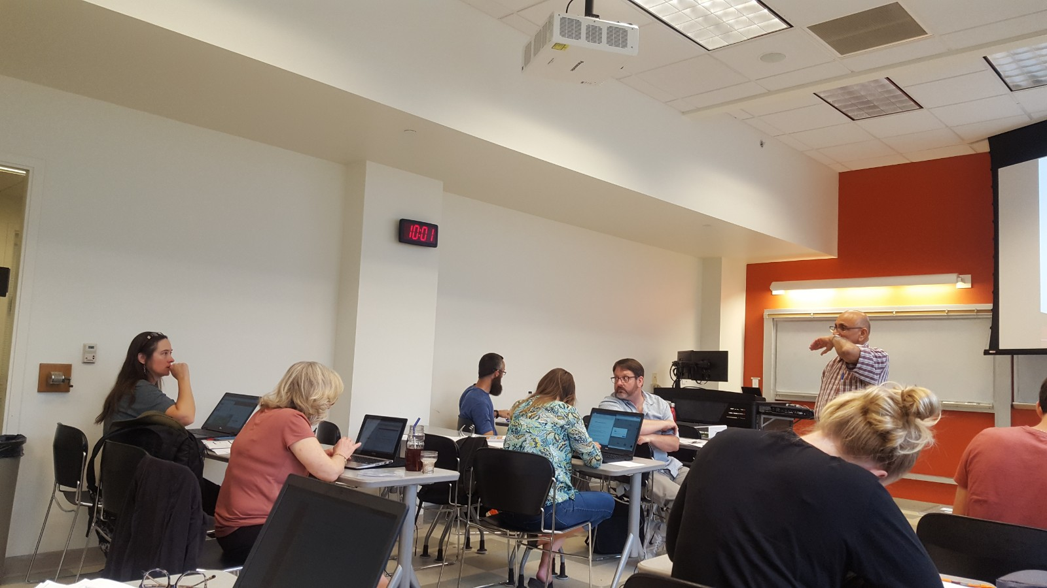  Figure 4: Dr. Kukreti Answers Questions

The next topic addressed was how to prepare a presentation. Dr. Kukreti explained the first step to preparing a presentation is to decide what type of presentation (PowerPoint or poster) you want to do and create an outline of the presentation. Since the requirement for RET is to create a PowerPoint presentation, Dr. Kukreti provided an example of an outline for a PowerPoint presentation for presenting a curricular unit produced by a teacher. Each part was discussed. Dr. Kukreti stated the title doesn’t have to be exact, but it should be catchy as to get the audience’s attention to the topic presented. Dr. Kukreti advised that everything in the presentation must relate to the title. The rest of the outline included the headings of the topics likely to be presented with a conclusion slide. Dr. Kukreti then related the discussion to the poster presentation. An example was provided and discussed. From this example, Dr. Kukreti provided a few tips such as using statements instead of complete sentences, using bullets and pictures, and using as few words as possible.

The final item discussed in Session 1 was the seminar assignment. Dr. Kukreti explained the assignment in detail. RET Participants were asked to first choose what type of presentation they plan to complete. Based on choice, RET Participants were asked to create an outline for their chosen presentation type, and present it in a 3-5 minute PowerPoint presentation for others to critique during the July 11, 2018 workshop session. Dr. Kukreti ended the session by asking for any questions, see Figure 4 above.

Session 2 of this workshop took place on the morning of July 11th and featured a short PowerPoint presentation by each RET Participant. After a brief period of instruction from Mrs. Debbie Liberi, the RET Participants took turns presenting their ideas for the group.

While presentation styles varied from one participant to the next, all information was conveyed clearly and effectively by each participant for their selected presentation. Also, the format and layout of each presentation varied slightlybut several similarities were evident. Each presenter included information about the concept of Challenge Based Learning (see Figure 5 below), since it formed the backbone of each participant’s instructional unit. Some presentations focused on defining Challenge Based Learning, while others mentioned its attributes or wove it into the description of their instructional unit. Another common feature of the presentations was the Engineering Design Process (EDP), since it is required procedure to be used to solve the challenge selected for each participant’s instructional unit. This concept was described by different participants in various levels of detail as it related to each participant’s planned challenge (see Figure 6 below).

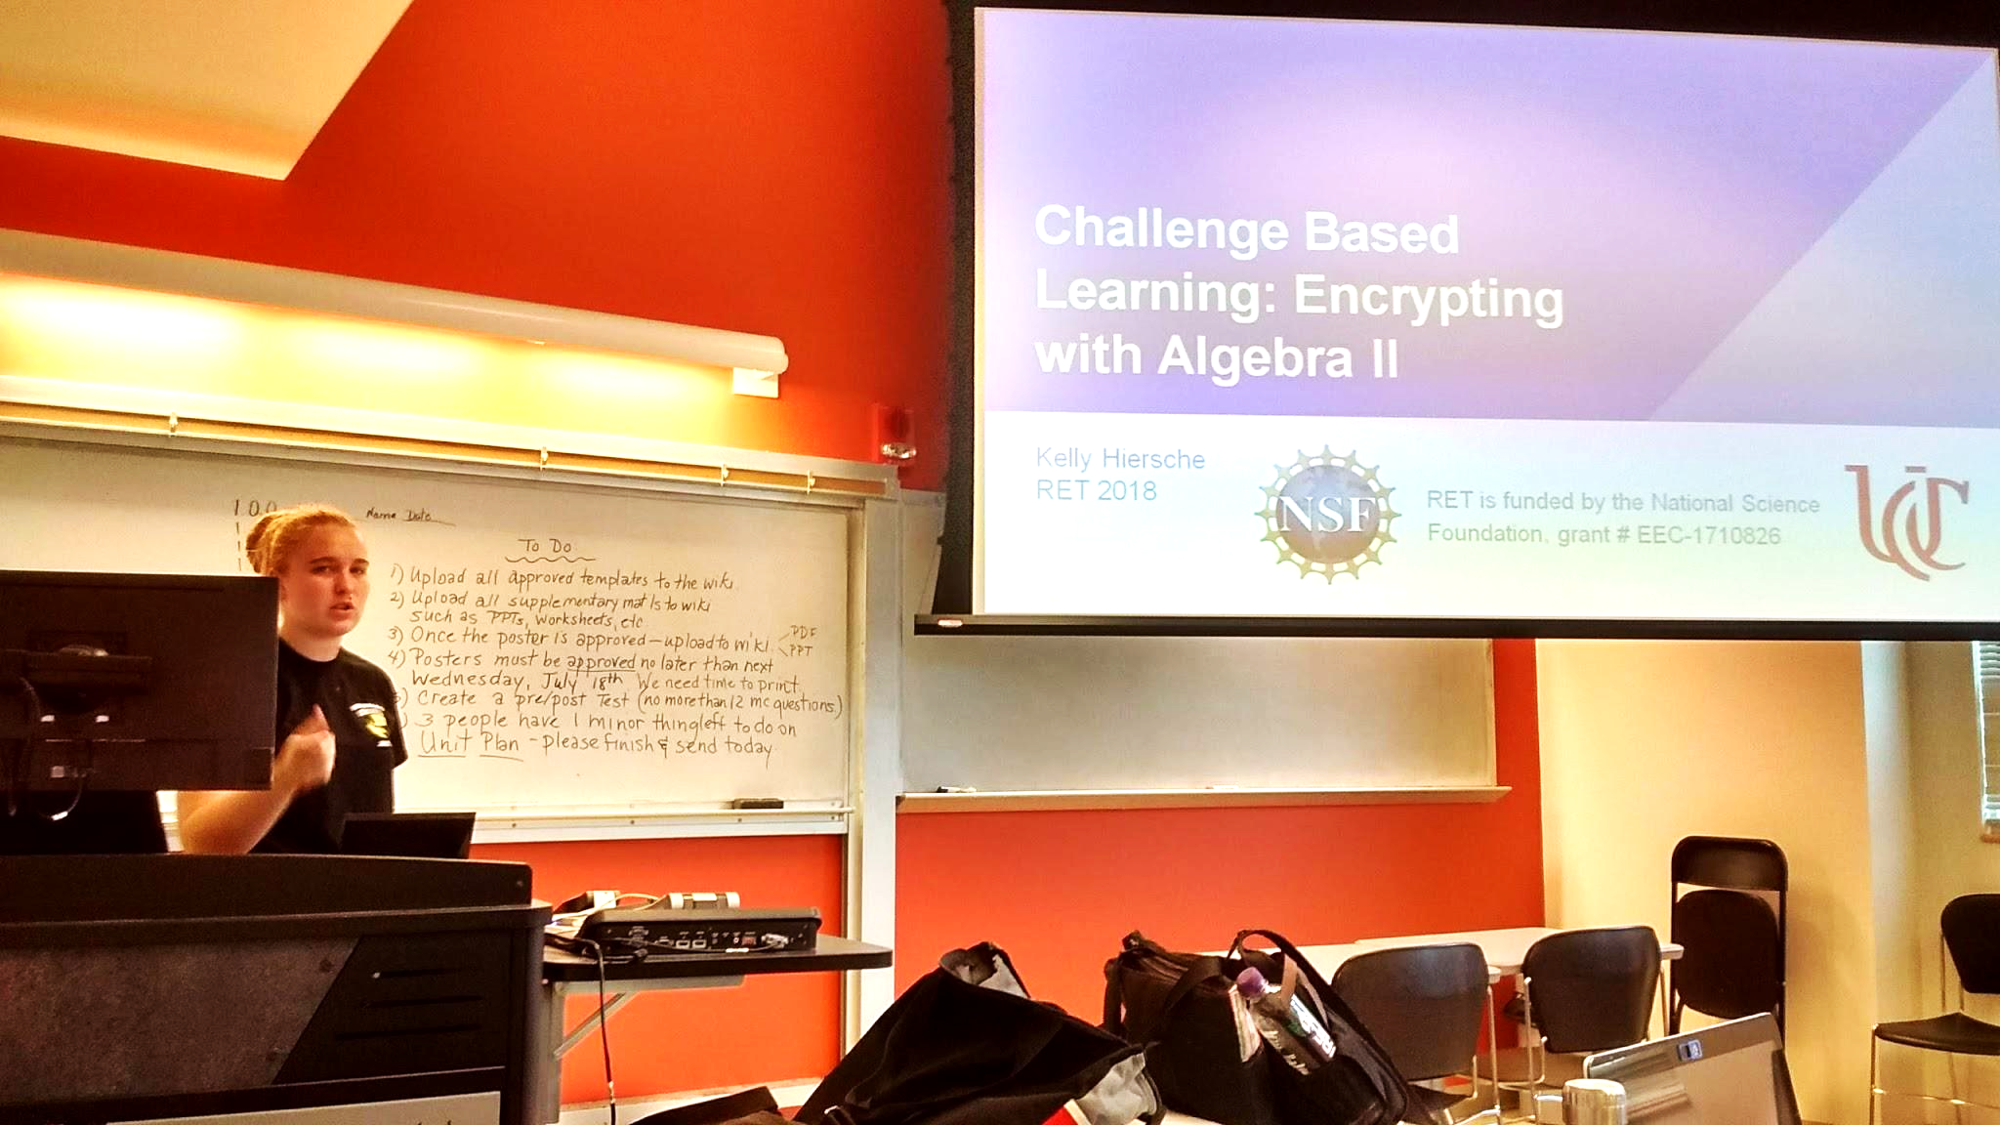  Figure 5: A Participant Explaining Challenge Based Learning | 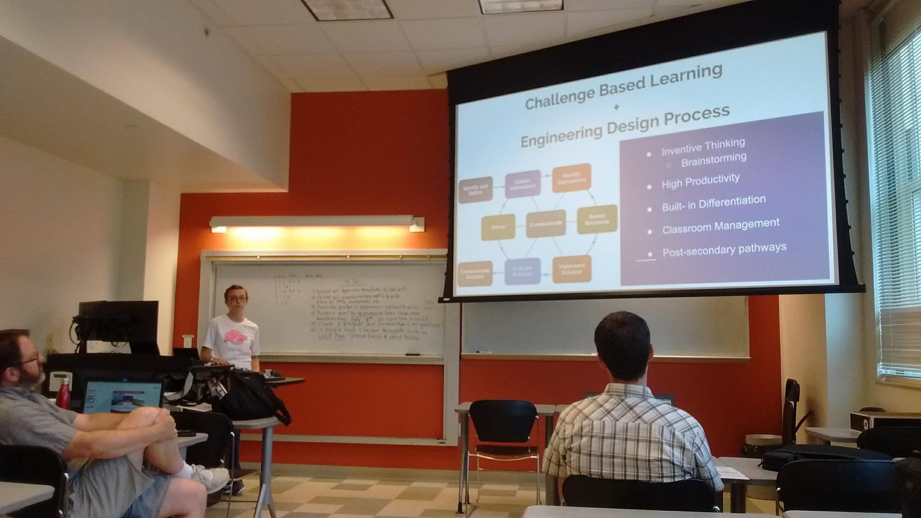  Figure 6: A Participant Describing the Engineering Design Process (EDP)

Several presentations included a strong focus on the description of the planned unit, with slides dedicated to the posting of student progress and testing outcomes. Other presentations showed slightly different foci, putting more of an emphasis on the research project and its ties to the instructional unit. Another difference was seen in the intended audiences for these presentations. Several participants planned to take these presentations back to their respective schools, where the information will be shared with colleagues. Others planned to present at a conference for Physics Teachers, hoping to reach an audience of teachers from many high schools and colleges.

At the conclusion of each presentation, the presenter received feedback from Mrs. Debbie Liberi and fellow RET Participants. Areas for improvement were identified in each presentation, and ideas were shared about how to remediate those areas. Exemplary work was also pointed out and praised, with the added benefit that many RET Participants gained new ideas for their respective presentations. The session ended with some timely feedback from Mrs. Debbie Liberi.

